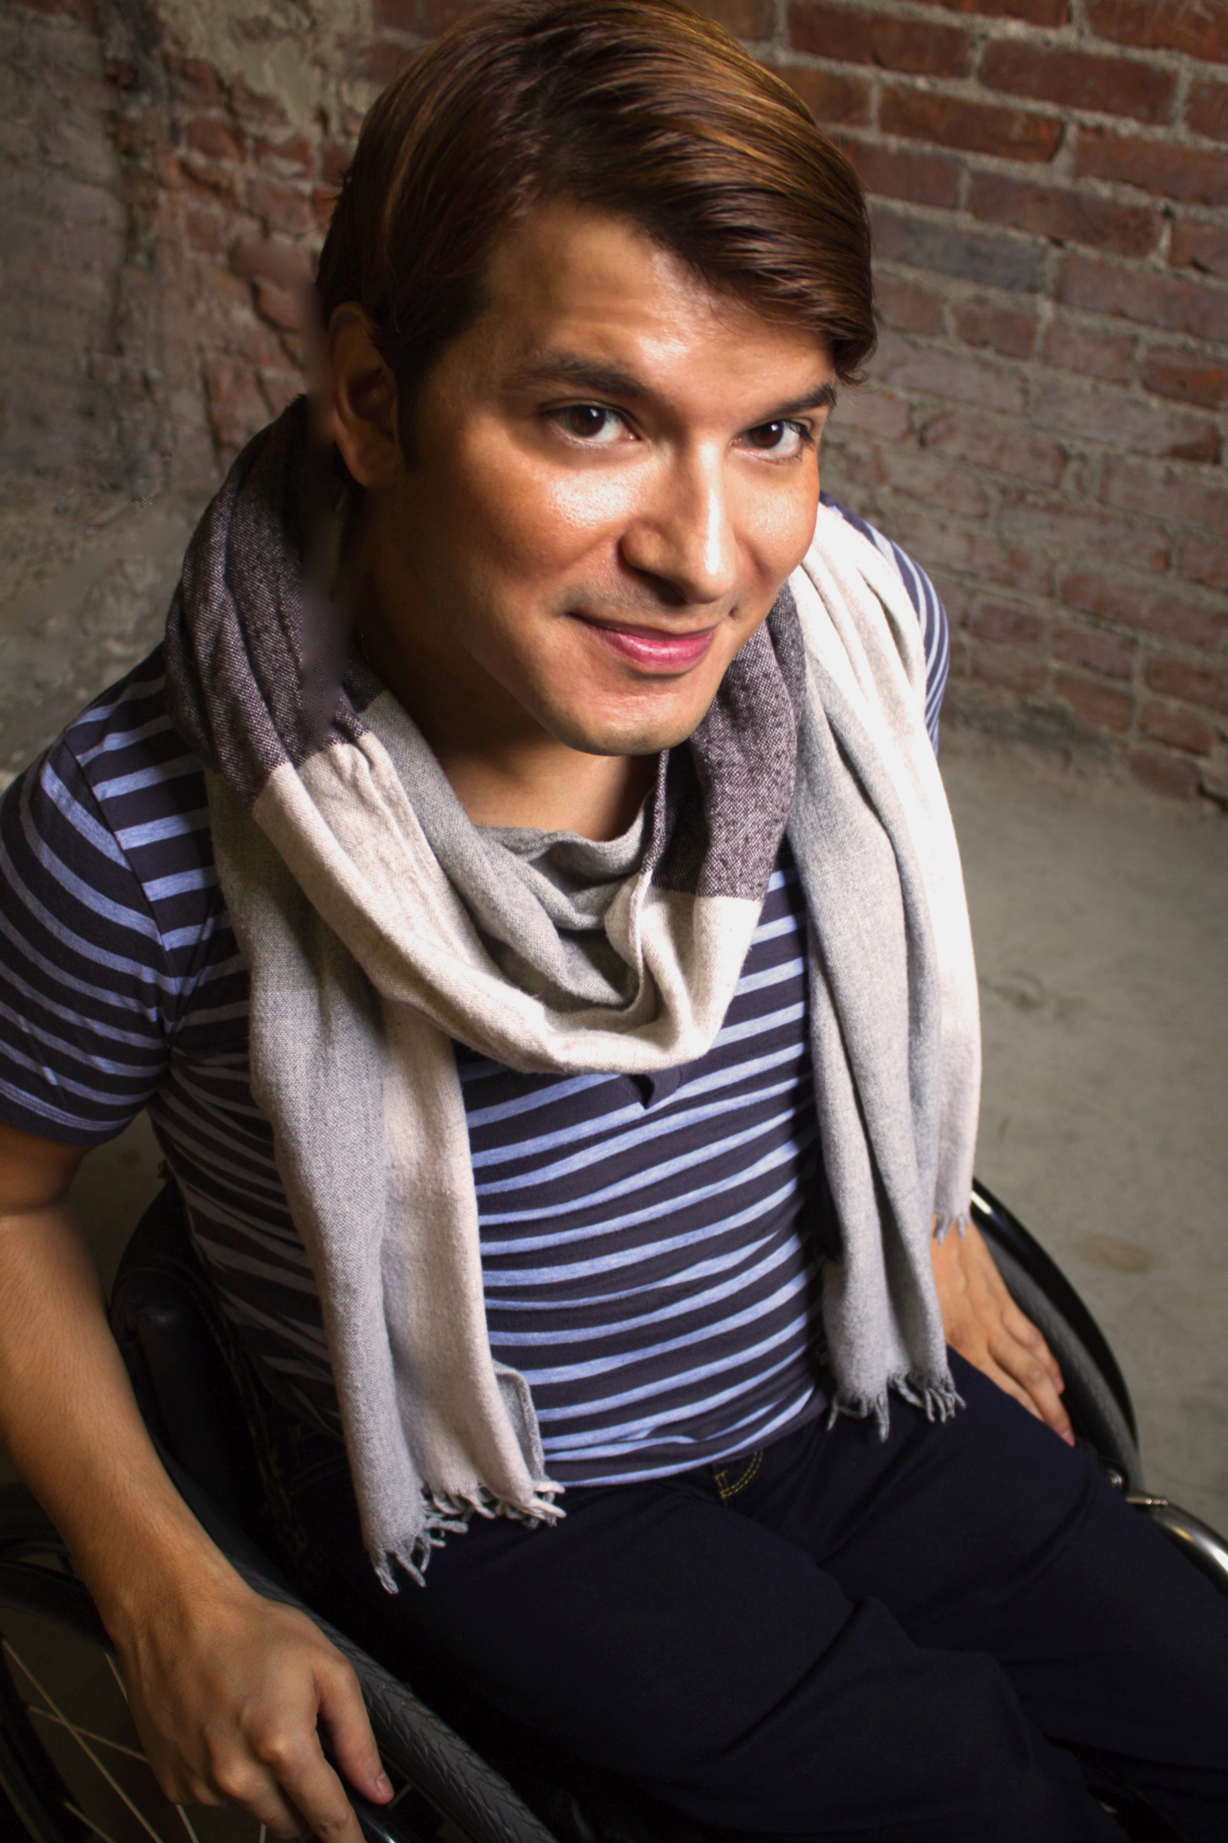
Andy L. Arias
Motivational Speaking and Training Highlights

LGBTQ/Disability Cross-section
OC Accept Orange County, CA 2013
Spoke to Orange County key stakeholders on the cross sections of disability and LGBTQIA.
Main topics of focus: What kinds of services are out there for individuals in the middle of this spectrum and how can we work better together in providing services to these underserve communities? How to safely have crossed inclusion within both communities?

Anti-bullying Training
Rancho Los Amigos Downey, CA 2013
Spoke to a large student audience about importance of safety.
Main topics of focus: What bullying means in a real world aspect? What does bullying look like today, working on some strategies on how to combat bullying realistically. Cultivating resources and strategic planning on ending bullying in schools.

ADA Training
Orange County Hard of Hearing Coalition Orange County, CA 2013
Spoke on ADA compliance and What the ADA in current times.
Main topics of focus: What strategic plans can be put in place to utilize legislators in the best way? How can we create greater avenues for compliance for the hard of hearing community?

Disability History Presentation
Cal State Fullerton Orange County, CA 2013
Spoke to a group of students majoring in disability policy, about disability history.
Main topics focus: Showed realities of the political movement in the disability community. Educated on the Holocaust through the disability perspective. Also showed the crossover between other civil rights movement and civil right movement for PWD and showcasing common threads between other minority groups such as Latin, African American, and LGBTQIA communities.

Employment Training
Molina Healthcare Long Beach, CA 2014
Spoke employers and perspective employees on the importance of hiring individuals with disabilities.
Main topics of focus: Educated on employment statistics PWD’s. Gave a realistic view of what it’s like to look for employment and having a disability. Created a knowledge base and strategic tools on how to work with diverse populations. Also provided them with variety of resources on employment right of people with disabilities

Best Practices for Students With Disabilities
OC Charter School Coalition Orange County, CA 2014
Spoke to teachers and school administrators on best practices for Students with disabilities.
Main topics of focus: building strategies on how advocate better at their IEP. Worked on strategies on developing curriculum and lesson plans for a diverse student population. How to work with the resources school districts have available in order to optimize services for students with disabilities.

Sexuality & Disability
Santa Ana School District Orange County, CA 2014
Spoke to Admin and staff at Santa Ana School District about sexual education programs for students with disabilities.
Main topics of focus: Sexuality within the disability community cannot be negated or ignored. Sexuality and sexual safety has to be educated in a proper non-condescending way for individuals to feel empowered and safe.

How To Build a Sustainable Youth Program
NCIL Washington DC 2014
Spoke to a group of advocates from IL’s around the country, on developing strategies for maintaining a youth program.
Main topics of focus Spoke on the development of advocacy groups. Diversifying the group and allowing group members to make the group they’re own. Maintaining the group’s interest in the long term. Creating successful team building skills within the group dynamic.

Hiring & Diverse Strategic Planning
Los Angeles Diversity Council Los Angeles County, CA 2015
Spoke to HR managers and employers about best practices for hiring individuals with disabilities.
Main topics of focus The importance of hiring qualified diverse groups of individuals so that their employees mirror the people that they want to serve. Giving them strategic strategies on reaching out to the disability community when looking for future employees. Provided mock interview training for HR stuff.

Developing Advocacy Groups
DoNetwork /CFILC Orange County, CA 2015
Spoke to ILC advocates about creating dynamic and sustainable advocacy groups within their organization.
Main topics of focus Starting off with peer groups in encouraging them to be more involved in the disability movement. Assuring that the group is consumer driven. Getting involved group members interest instead of making it all about the issues.

Sexual Assault Within the Disability Community
Sexual Assault Coalition Los Angeles, CA 2015
Spoke to a group of sexual assault advocates across the nation to advise them on best practices working with individuals with disabilities.
Main topics of focus Worked on some strategic planning details on how to engage the disability community when it comes to reporting sexual assault. Developing plans to lessen sexual assaults within skilled nursing facilities and foster homes. Developing sexual safety trainings within ILC’s, Regional Centers and other organizations that work with PWD’s

National-Federal Speaking Engagements
(to be updated)

Georgetown University
(to be updated)

This is a highlighted list of Keynote workshops, trainings or speeches that I’ve done. I have had over 50 engagements including being a panelist at several events.

